Registration Process for Suppliers Directory – 5 Short Steps to feature in the directory

What we need are your details – your areas of experise – what Categories of Subjects you wish to be aligned with in the encyclopedia’

Step 1

Select ‘Register Now’ on the Blue band (under the red Contact Us).

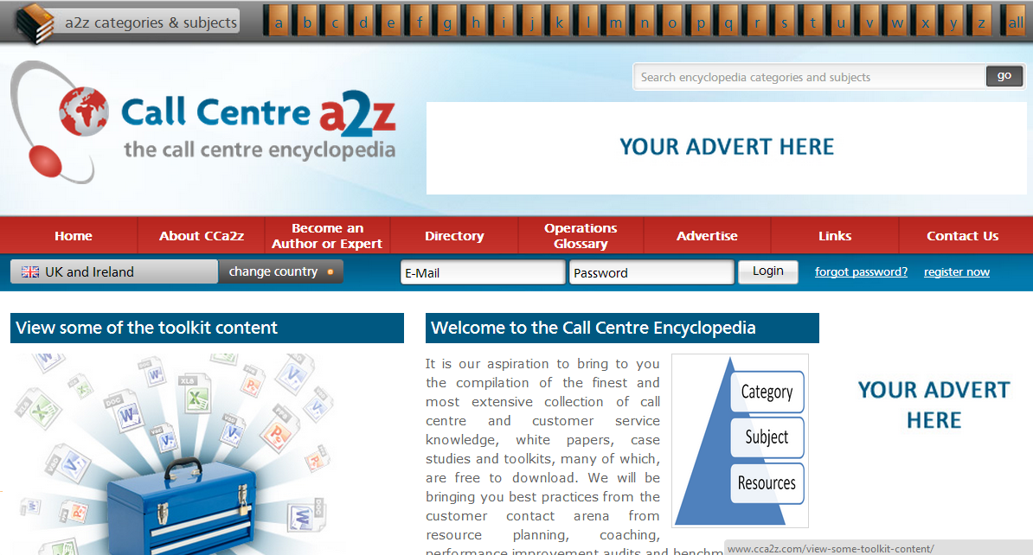
Step 2

Complete the Registration Fields

Step 3

To feature in the suppliers directory, select the Blue band at the end of the registartion process - Suppliers: Feature in our supplier Directory – click here
This takes you to the fields which will display in your profile on site.
Step 4

- Select up to 10 areas of Expertise (these are the filters our Users will select when searching) – click ‘Expand All’ to view all areas of expertise.
- Complete all the fields which will display exactly the same in the directory as input – Company name, profile information, contact details and logo upload.

Step 5

OK you are nearly there, having uploaded your logo you are now into the Category zone.
- Select ‘Expand All’ to view all the categories
- Select upto 5 of the most relevant encyclopedia categories. Each Category is full of Subjects (If you want to see what subjects are in a category, simply select ‘View Subjects’ next to the category name). Users will view resources by the subject they select – so by selecting a category you will appear in each of it’s subject resources
- Then simply input your verification code as shown and hit submit. We will then take a moment to approve your directory registartion

This is how your listing would appear in the search with a search by expertise or subject

Users could click on your profile to find more details and contact number / send an email or select your website.

This is how the supplier listing looks on a subject page

